EXPERIMENT 31
Implement Image Segmentation Using OpenCV Based on Threshold Values
Aim:
To segment an input image based on the given threshold value using Python and OpenCV.
Procedure:
- Import OpenCV.
- Read the input image.
- Convert the image into grayscale.
- Enter the threshold value.
- Apply thresholding using cv2.threshold().
- Display the segmented image.
Program:
import cv2

img = cv2.imread(r"D:\Amrita\Pictures\Screenshots\Screenshot 2026-09-30 143819.png")

gray = cv2.cvtColor(img, cv2.COLOR_BGR2GRAY)

ret, thresh = cv2.threshold(gray, 127, 255, cv2.THRESH_BINARY)

cv2.imshow("Original Image", img)
cv2.imshow("Segmented Image", thresh)

cv2.waitKey(0)
cv2.destroyAllWindows()
Input:

Output:
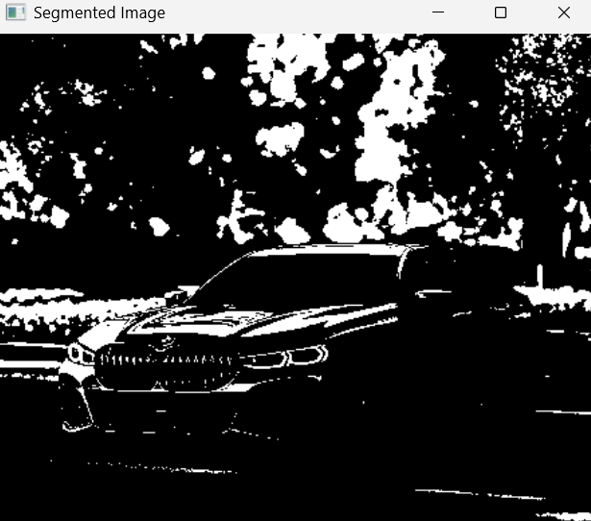
Result:
Thus, image segmentation was successfully performed using the given threshold value in OpenCV.

